**Cetak Barang (Pertemuan ke 13)**

* Jalankan XAMPP terlebih dahulu

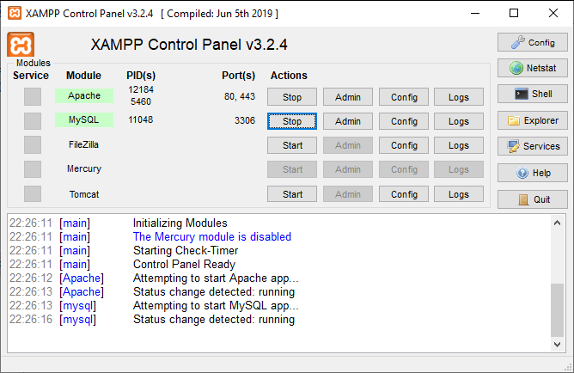

Program 01 :

Output program :

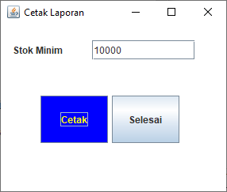

Hasil disimpan di Pdf :

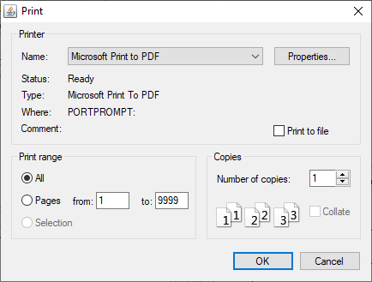

Isikan nama file pdfnya

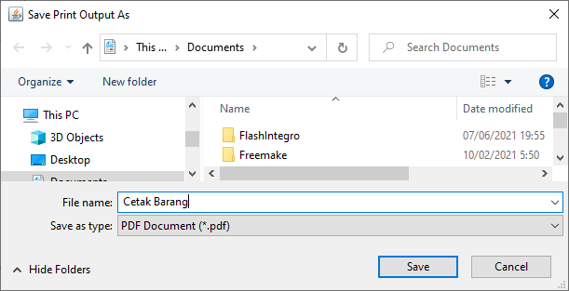



Output :

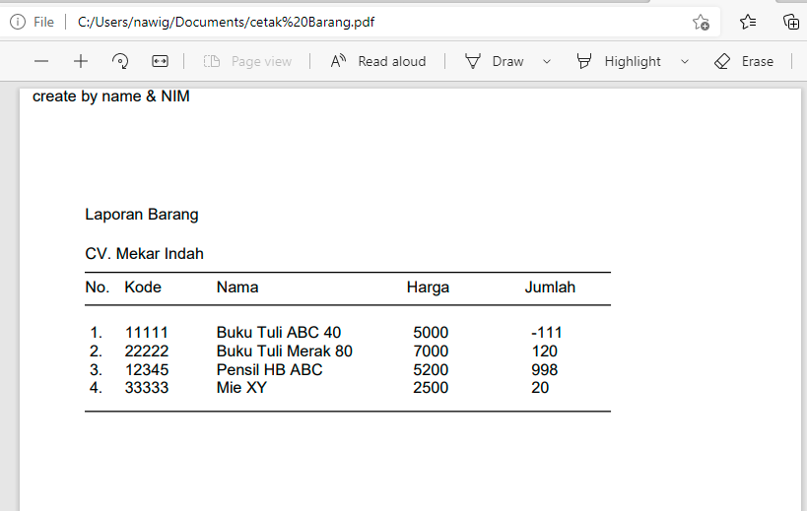

kode program sebagai berikut :

import java.awt.Graphics;

import java.awt.print.PageFormat;

import java.awt.print.Printable;

import java.awt.print.PrinterException;

import java.awt.print.PrinterJob;

import javax.swing.JPanel;

import java.awt.*;

import java.awt.event.*;

import java.io.*;

import javax.swing.*;

import java.sql.*;

import javax.swing.table.DefaultTableModel;

public class CetakBarangMin06284 extends JFrame implements ActionListener

{

private JPanel pBrg = new JPanel();

private JLabel lMinim = new JLabel ("Stok Minim ");

private JTextField fKode = new JTextField ();

private JButton btnAdd = new JButton (),

btnSelesai = new JButton ();

private ResultSet rs;

String[] header = {"Kode","Nama","Harga Beli"};

DefaultTableModel tabMode1;

JTable tabel = new JTable();

JScrollPane skrTabel = new JScrollPane();

Integer isikanjml = 5;

public CetakBarangMin06284() {

setPreferredSize(new Dimension(300,250));

setTitle("Cetak Laporan");

setDefaultCloseOperation(JFrame.EXIT_ON_CLOSE);

new BorderLayout();

JDesktopPane pBrg = new JDesktopPane();

add(pBrg, BorderLayout.CENTER);

/* Mengatur letak objek Label Di container*/

lMinim.setBounds (15, 20, 100, 25);

/* Mengatur letak objek Text Di Container */

fKode.setBounds (115, 20, 130, 25);

/* Mengatur letak objek Button di Container */

btnAdd.setBounds (50, 90, 85, 60);

btnAdd.setLabel("Cetak");

btnAdd.setBackground(Color.BLUE);

btnAdd.setForeground(Color.getHSBColor(250,0,255));

btnSelesai.setBounds (140, 90, 85, 60);

btnSelesai.setLabel("Selesai");

btnSelesai.setToolTipText("Mengakhiri Program");

/* Objek Button di Non Aktifkan dan di aktifkan */

btnAdd.setEnabled(true);

btnSelesai.setEnabled(true);

// Mengatur objek untuk dapat berinteraksi

btnAdd.addActionListener (this);

btnSelesai.addActionListener (this);

// Meletakkan seluruh kontrol pada objek panel */

pBrg.add (lMinim);

pBrg.add (fKode);

pBrg.add (btnAdd);

pBrg.add (btnSelesai);

/* Menambahkan objek panel (pBrg) ke container frame */

//getContentPane().add (pBrg);

/* Menampilkan frame ke layar monitor */

pack();

setLocationRelativeTo(null);

setVisible (true);

}

public static void main(String[] args) {

new CetakBarangMin06284().setVisible(true);

}

/* Fungsi jika user melakukan action penekanan tombol Button */

public void actionPerformed (ActionEvent ae) {

Object obj = ae.getSource();

if (obj == btnAdd)

{

CetakOK();

}

if (obj == btnSelesai)

{

//System.exit(0);

this.dispose();

}

}

// Fungsi untuk menambahkan data ke tabel barang

void CetakOK()

{

try {

PrinterJob pjob = PrinterJob.getPrinterJob();

pjob.setJobName("Graphics Demo Printout");

pjob.setCopies(1);

pjob.setPrintable(new Printable()

{

public int print(Graphics g1, PageFormat pf, int pageNum) {

if (pageNum > 0) // we only print one page

return Printable.NO_SUCH_PAGE; // ie., end of job

g1.drawString("create by name & NIM", 10, 10);

//cetak data....................................

try

{

//Koneksi ke table barang..................

KoneksiDBMS CnPenjualan = new KoneksiDBMS();

Connection con = CnPenjualan.BukaCn();

Statement stat = con.createStatement();

isikanjml = Integer.parseInt(fKode.getText());

String strsql = "SELECT * FROM barang06284 where jumlah <= '" + isikanjml + "'";

ResultSet rs = stat.executeQuery(strsql);

int i1, x1, y1;

//Header

g1.drawString("Laporan Barang", 50, 100);

g1.drawString("CV. Mekar Indah", 50, 130);

g1.drawLine(50, 140, 450, 175);

g1.drawString("No.", 50 ,155);

g1.drawString("Kode", 80, 155);

g1.drawString("Nama", 150, 155);

g1.drawString("Harga", 295, 155);

g1.drawString("Jumlah", 582, 155);

g1.drawLine(50, 125, 450, 165);

x1 = 50;

y1 = 190;

i1 = 1;

//Cetak Record Barang.................

while(rs.next())

{

g1.drawString(" " + i1 + ".", 50, y1);

g1.drawString(rs.getString(1),80,y1);

g1.drawString(rs.getString(2),150,y1);

g1.drawString(rs.getString(3),300,y1);

g1.drawString(rs.getString(5),390,y1);

y1 += 14;

i1++;

}

g1.drawLine(x1, y1, 450, y1);

rs.close();

con.close();

}

catch(Exception e)

{

System.out.println("Ada Kesalahan !");

}

return Printable.PAGE_EXISTS;

}

});

if (pjob.printDialog() == false) // choose printer

return;

pjob.print();

} catch (PrinterException pe) {

pe.printStackTrace();

}

}

}

Program 02 :

kode program :

**cetak barang keseluruhan**

import java.awt.Graphics;

import java.awt.print.PageFormat;

import java.awt.print.Printable;

import java.awt.print.PrinterException;

import java.awt.print.PrinterJob;

import java.sql.*;

import javax.swing.JPanel;

public class CetakBarang06284 extends JPanel {

public static void main(String[] args) {

try {

PrinterJob pjob = PrinterJob.getPrinterJob();

pjob.setJobName("Graphics Demo Printout");

pjob.setCopies(1);

pjob.setPrintable(new Printable()

{

public int print(Graphics g1, PageFormat pf, int pageNum) {

if (pageNum > 0) // we only print one page

return Printable.NO_SUCH_PAGE; // ie., end of job

g1.drawString("Dewi P.AyuN 06284", 10, 10);

//cetak data....................................

try

{

//Koneksi ke table barang..................

KoneksiDBMS CnPenjualan = new KoneksiDBMS();

Connection con = CnPenjualan.BukaCn();

Statement stat = con.createStatement();

String strsql = "SELECT * FROM barang06284";

ResultSet rs = stat.executeQuery(strsql);

int i1, x1, y1;

//Header

g1.drawString("Laporan Barang", 50, 100);

g1.drawString("CV. Mekar Indah", 50, 130);

g1.drawLine(50, 140, 500, 140);

g1.drawString("No.", 50 ,155);

g1.drawString("Kode", 80, 155);

g1.drawString("Nama", 150, 155);

g1.drawString("Harga", 300, 155);

g1.drawString("Harga", 320, 155);

g1.drawLine(50, 165, 500, 165);

x1 = 50;

y1 = 190;

i1 = 1;

//Cetak Record Barang.................

while(rs.next())

{

g1.drawString(" " + i1 + ".", 50, y1);

g1.drawString(rs.getString(1),80,y1);

g1.drawString(rs.getString(2),150,y1);

g1.drawString(rs.getString(3),300,y1);

g1.drawString(rs.getString(4),450,y1);

y1 += 14;

i1++;

}

g1.drawLine(x1, y1, 500, y1);

rs.close();

con.close();

}

catch(Exception e)

{

System.out.println("Ada Kesalahan !");

}

return Printable.PAGE_EXISTS;

}

});

if (pjob.printDialog() == false) // choose printer

return;

pjob.print();

} catch (PrinterException pe) {

pe.printStackTrace();

}

}

}

Selamat mencoba